Magnetic Resonanvce Imaging (MRI) :
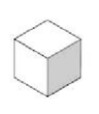Voxel
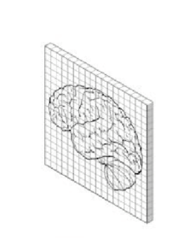Individual Slice
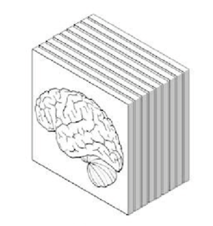Slices
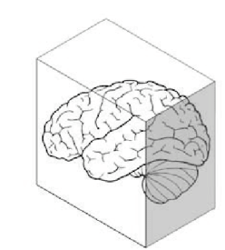Volume
Medical imaging of the brain can be performed using MRI, PET, or CT scans. In this project, we focus primarily on MRI scans, which generate high-resolution 3D images of the brain. To compare 2D and 3D scans, consider that a voxel in a 3D scan serves a similar role to a pixel in a 2D scan. A voxel is created by capturing images in successive planes at regular intervals, essentially extending a pixel into the third dimension. Magnetic Resonance Imaging (MRI) is a powerful imaging technique used to visualize internal body structures, especially soft tissues.

Physical Principles
MRI leverages the magnetic properties of hydrogen nuclei in water molecules. In a strong magnetic field, these nuclei align and emit radiofrequency (RF) signals upon excitation. The scanner detects and processes these signals to form detailed 3D images.

Image Components
- Main Magnet: Produces a strong, uniform magnetic field (typically 1.5–3 Tesla clinically).
- Gradient Coils: Enable spatial encoding by varying magnetic fields.
- RF System: Sends RF pulses and receives emitted signals for image reconstruction.

Commonly Used MRI Sequences in Alzheimer’s Research:
T1 and T2 refer to two fundamental relaxation times that describe how hydrogen protons in tissues respond to magnetic fields and radiofrequency pulses during MRI.
- T1-Weighted (T1w):
  - Provides high anatomical detail.
  - Tissues with high fat content (like white matter in the brain) have shorter T1 times and appear bright on T1-weighted images, while fluids (like cerebrospinal fluid) have long T1 times and appear dark
  - Ideal for segmenting brain structures such as the hippocampus and cortex.
  - Used frequently in structural MRI (sMRI) pipelines.
- T2-Weighted (T2w):
  - Highlights fluid and pathological changes (e.g., edema, lesions).

Anatomical Imaging Planes: Etymology & Orientation
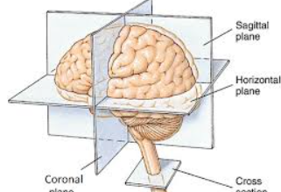

Axial Plane
- Orientation: Horizontal slice; divides the body into superior (top) and inferior (bottom).
- Use Case: Common for slice-wise CNN models in neuroimaging.

Coronal Plane
- Orientation: Vertical slice from ear to ear; separates anterior (front) and posterior (back).
- Use Case: Helpful for viewing cortical atrophy progression.

Sagittal Plane
- Orientation: Vertical slice dividing left and right hemispheres.
- Use Case: Critical for midline structure analysis, including corpus callosum integrity.
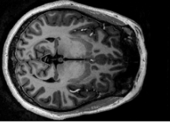Coronal
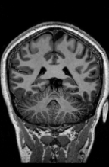Saggital
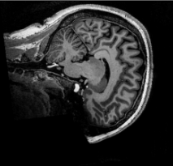Axial

